**“TECB SPORTS MANIA”**

**“COLLEGE SPORTS MANAGEMENT SYSTEM”**

A project report submitted in partial fulfillment of

the requirements for the award of the degree of

***BACHELOR OF TECHNOLOGY***

(Department of COMPUTER SCIENCE & ENGINEERING)

(BATCH 2021-2024)

***Submitted by***

**NameRoll No.Registration No.**

Payel Ghosh 24400121068 212440100120006 OF 2021-22

Subha Roy 24400121070 212440100120008 OF 2021-22

Dibiya Sarkar 24400121071 212440100120004 OF 2021-22

***Under the esteemed guidance of –***

**MRS. SULEKHA DAS**

***Submitted To***

 

**TECHNO ENGINEERING COLLEGE BANIPUR**

­­­­­ is affiliated to

**MAULANA ABUL KALAM AZAD UNIVERSITY OF TECHNOLOGY**

(Formerly known as **West Bengal University of Technology**

**To Whom It May Concern**

This is to certify that the project entitled “TECB SPORTS MANIA :College Sports Management System” is being submitted by *PAYEL GHOSH (24400121068), SUBHA ROY (24400121070), DIBIYA SARKAR (24400121071)* in partial fulfillment of the requirement for the award of the degree of BACHELOR OF TECHNOLOGY in the department of COMPUTER SCIENCE & ENGINEERING from TECHNO ENGINEERING COLLEGE BANIPUR (affiliated to MAULANA ABUL KALAM AZAD UNIVERSITY OF TECHNOLOGY).

**Signature of the Project Guide Signature of the Signature of the Principal Sir**

**MRS. SULEKHA DAS Head of the Dept. DR. MALOY KUMAR CHANDRA**

**Asst. Professor, Dept. of CSE & IT DR. HARI NARAYAN KHAN Techno Engineering College Banipur**

**Assoc. Professor, Dept. of CSE & IT**

**Certificate of Approval**

This is to certify that the thesis entitled **“TECB SPORTS MANIA** : **College Sports Management System”** is a bona fide record of work carried out by ***PAYEL GHOSH, SUBHA ROY, DIBIYA SARKAR*** in partial fulfillment of the requirements for the award of the degree of **BACHELOR OF TECHNOLOGY** in the department of **COMPUTER SCIENCE & ENGINEERING, TECHNO ENGINEERING COLLEGE BANIPUR** during the period 2021 to 2024. It is understood that by this approval the undersigned do not necessarily endorse or approve any statement made, opinion expressed or conclusion is drawn therein but approve the thesis only for the purpose for which it has been submitted.

**Signature of the Examiner(s)**  **Signature of the Supervisor(s)**

**ACKNOWLEDGEMENT**

The writing of this thesis as well as the related work has been a long journey with input from many individuals, right from the first day till the development of the final product.

With our most sincere respect and gratitude, we would like to thank ***MRS. SULEKHA DAS & DR. HARI NARAYAN KHAN***, our supervisors, for this overwhelming support throughout the duration of this project. Their motivation always gave us the required inputs and momentum to continue with our work, without which the project work would not have taken its current shape. Their valuable suggestions and numerous discussions have always inspired new ways of thinking. As a person too, we will never forget their immense support in times of crisis, without which we would most definitely have failed to complete this thesis. We feel deeply honored that we got this opportunity to work with them.

We would like to thank all the Faculty Members of the Department of ***Computer Science & Engineering*** for their continuous support.

Last, but not least, we would like to thank all the members of the ***Lab Assistants*** for providing us with lab facilities when required and our batch mates of the ***Bachelor of Technology in Computer Science & Engineering*** & batch of ***2021-2024*** in ***Techno Engineering College Banipur*** for staying by our side when we needed them.

**PAYEL GHOSH SUBHA ROY DIBIYA SARKAR**

**CSE ( 24400121068 ) CSE ( 24400121070 ) CSE ( 24400121071 )**

**DECLARATION OF ORIGINALITY AND COMPLIANCE OF ACADEMIC ETHICS**

We, hereby declare that the thesis contains a literature survey and original research work by the undersigned candidates and the project report entitled **“TECB SPORTS MANIA: College Sports Management System”** is submitted in partial fulfillment of the requirement for the award of the degree of **BACHELOR OF TECHNOLOGY in COMPUTER SCIENCE & ENGINEERING**.

We hereby declare that all information in this document has been obtained and presented by academic rules and ethical conduct.

We also declare that, as required by these rules and conduct, we have fully cited and referenced all material and results that are not original to this work.

**PAYEL GHOSH SUBHA ROY DIBIYA SARKAR**

**CSE ( 24400121068 ) CSE ( 24400121070 ) CSE ( 24400121071 )**

**INDEX Page No.**

**1. Abstract ------------------------------- 7**

**2. Introduction ------------------------------- 8**

**3. Problem Definition ------------------------------- 9**

3.1) Problem Definition

3.2) Problem Statement

3.3) Solution

**4. Method ------------------------------- 10**

**5. Project Category ------------------------------- 11-12**

**6. Tools & Environment used ------------------------------- 13**

**7. System Requirements specifications (SRS) -------------------------------- 14-15**

**8. Post Development Management ------------------------------- 16-17**

**9. Project Procedure ------------------------------- 18**

**10. Analysis ------------------------------- 19-20**

**11. Data Flow Diagram ------------------------------- 21-23**

11.1) Level 0 DFD

11.2) Level 1 DFD

11.2) Level 2 DFD

**12. Use Case Diagram ------------------------------- 24**

**13. Output ------------------------------- 25-29**

**14. Report Generation ------------------------------- 30**

**15. Scope & Further Enhancement ------------------------------- 31**

**16. Conclusion ------------------------------- 32**

**17. Reference ------------------------------- 33**

**1.ABSTRACT**

The TECB Sports Mania project is a web application designed to simplify the registration process and management of sports events organized by the TECB organization. It offers a user-friendly platform for participants to easily register for various sports events and for organizers to efficiently manage event logistics and participant data. The platform includes features such as intuitive registration processes, event management tools, participant data management, communication features, scalability, customization options, and robust security measures to ensure data privacy. Overall, it aims to streamline the administrative tasks associated with organizing sports events and provide a seamless experience for both participants and organizers.

**2.INTRODUCTION**

TECB SPORTS MANIA is a web-based sports management platform designed to simplify sports-related tasks using modern technology. It offers a range of tools for organizing events, managing teams, and tracking player performance. Built using HTML, CSS, and JavaScript, the platform ensures an intuitive user experience and seamless functionality. By leveraging MySQL for data storage, TECB SPORTS MANIA provides a secure and reliable database system. Its user-friendly interface and scalable architecture make it suitable for sports enthusiasts, teams, and event organizers of all levels. With features such as event scheduling, team coordination, and player statistics tracking, the platform aims to enhance efficiency and collaboration within the sports community. TECB SPORTS MANIA represents a technological advancement in sports management, promising to streamline processes and improve the overall sports experience.

**3. PROBLEM DEFINITION & SOLUTION**

**3.1 Problem Definition:**

College sports management often faces challenges in efficiently organizing and managing various aspects of sports events, teams, and athletes. Traditional methods of managing sports activities, such as manual record-keeping and communication, can be time-consuming, error-prone, and inefficient.

**3.2 Problem Statement:**

At TECB, students struggle with outdated sports management methods, leading to delayed updates, scheduling conflicts, and poor communication. Manual processes hinder their ability to stay organized and engaged in sports activities. Students miss important information, such as match schedules and team announcements, impacting their participation and overall sports experience negatively. To address this, there's a need for a centralized, user-friendly solution that provides real-time updates, streamlines communication, and enhances accessibility to sports-related information.

**3.3 Solution:**

Introducing TECB SPORTS MANIA, a centralized sports management platform tailored specifically for TECB students, offers a solution to these challenges. This platform provides real-time updates on match schedules, venue changes, and team announcements, ensuring students stay informed and engaged. With features like automated scheduling, instant messaging, and easy access to sports-related information, TECB SPORTS MANIA streamlines communication, enhances organization, and improves the overall sports experience for students at TECB.

**4.METHOD**

The development of the TECB Sports Mania system will follow an agile methodology, emphasizing collaboration, flexibility, and rapid adaptation to changing requirements. The project will be divided into several sprints, each focusing on specific features and functionalities, allowing for iterative development and continuous improvement.

The initial phase will involve gathering comprehensive requirements from key stakeholders, including students, athletic department staff, coaches, and college administrators. This process will ensure a deep understanding of the diverse needs, preferences, and pain points of the target audience, which will inform the system's design and development.

The design phase will be a collaborative effort between user experience (UX) experts, visual designers, and developers. Wireframes and mock-ups will be created to visualize the system's layout, navigation, and overall user experience. Responsive design principles will be incorporated to ensure optimal performance across various devices and screen sizes.

During the development phase, a team of skilled developers will implement the system's core functionalities using modern web technologies such as HTML5, CSS3, JavaScript, and server-side scripting languages like PHP and Node.js. Version control systems and collaborative development tools will be utilized to ensure efficient code management and seamless collaboration among team members.

Throughout the development process, iterative testing and quality assurance measures will be implemented to identify and resolve any bugs or issues. Feedback from stakeholders, including students, coaches, and athletic staff, will be continuously sought and incorporated to refine and enhance the system.

Overall, this agile, collaborative approach will enable the TECB Sports Mania system to evolve and adapt based on real-world feedback, ensuring it meets the changing needs of the college sports community.

**5. PROJECT CATEGORY**

TECB SPORTS MANIA is categorized as a web-based sports management platform. It serves as an online hub for college sports enthusiasts, providing features for organizing, tracking, and engaging with various sports events, teams, and athletes. As a web-based platform, it offers convenient accessibility from any internet-connected device.

* **Front-end:**
* **HTML (HyperText Markup Language)** serves as the backbone of web pages, providing the essential structure and content for displaying information on browsers. In TECB SPORTS MANIA, HTML is utilized to construct the fundamental layout and elements of the website, including headers, navigation bars, content sections, forms, and buttons. This ensures that the content is semantically structured, accessible, and consistent across various browsers and devices.
* **CSS (Cascading Style Sheets)** is responsible for enhancing the visual appeal and user experience of web pages by styling HTML elements. Within TECB SPORTS MANIA, CSS is employed to define the presentation aspects of the website, such as colors, fonts, layouts, spacing, and responsiveness. This contributes to maintaining design consistency, improving readability, and providing a cohesive visual identity throughout the platform.
* **JavaScript (often shortened to JS)** plays a pivotal role in adding interactivity and dynamic functionality to web pages, facilitating real-time updates, form validation, animations, and user interactions. In TECB SPORTS MANIA, JavaScript is utilized to implement interactive features like dropdown menus, sliders, modal dialogs, and form validations. This enhances user engagement, usability, and facilitates seamless interaction with various elements and functionalities of the platform.
* **BACK-END:**
* **Node.js** is a platform built on Chrome's JavaScript runtime for easily building fast and scalable network applications. Nods uses an event-driven, non-blocking I/O model that makes it lightweight and efficient, perfect for data-intensive real-time applications that run across distributed devices.
* **Express.js** For developing the restful APIs.
* **Database:**

**MySQL:**

* In the TECB SPORTS MANIA project, MySQL serves as the back-end database management system. MySQL is utilized to efficiently store and manage structured data related to various aspects of the sports management platform, including user profiles, match schedules, team details, and performance statistics. Through MySQL, data is organized into tables with defined relationships, allowing for optimized data storage, retrieval, and manipulation. The integration of MySQL with the back-end logic ensures seamless interaction between the application and the database, enabling smooth operation and efficient management of sports-related information. Additionally, MySQL provides features such as transaction support and robust security measures to ensure data integrity, reliability, and confidentiality within the TECB SPORTS MANIA platform.

**6. TOOLS/ENVIRONMENT USED**

* **Hardware we used:**
* Processor : Intel i3
* Ram : 4GB
* Hard disk : 512GB SSD
* **Software we used:**
* Operating System : Windows 10 Home

* Front End : HTML – CSS, JAVASCRIPT
* Back End : Node.js, Express.js
* Database : MySQL
* Web Browser : Chrome
* Code Editor : Visual Studio Code

**7. SYSTEM REQUIREMENTS SPECIFICATION**

* **Project Background:**

TECB SPORTS MANIA aims to modernize college sports management by providing a centralized platform for students, Faculty, and organizers at TECB. The platform addresses challenges faced by manual methods, offering real-time updates, and enhanced organization.

* **Requirement Identification:**

Define user roles, functional features, technical specifications, non-functional requirements, and constraints to guide the project development.

* **Functional Requirements:**
* **User Registration and Authentication**: Participants and organizers will be able to create accounts and securely authenticate themselves.
* **Event Registration**: Participants can browse and register for various sports events organized by TECB.
* **Event Management**: Organizers can create, update, and manage sports events, including details such as event name, date, time, venue, and participant limit.
* **Participant Management**: Organizers can view and manage registered participants, generate participation lists, and communicate with participants through the application.
* **Scheduling and Venue Management**: Organizers can assign venues and create schedules for events, ensuring efficient resource allocation and minimizing conflicts.
* **Notifications and Updates**: Participants and organizers will receive timely notifications and updates regarding event schedules, changes, and important announcements.
* **Reporting and Analytics**: The application will generate reports and provide analytics on event participation, organizer performance, and overall sports event trends.
* **Technical Requirements:**

1. **Validation:** TECB SPORTS MANIA ensures that any information entered by users is accurate, consistent, and secure. It involves checking the data to ensure it meets certain criteria, such as format, length, and range, to prevent errors or unauthorized access. This process helps maintain the integrity of the data and ensures that the system functions correctly, providing a reliable and trustworthy experience for users interacting with the platform.
2. **Statistics:** In TECB SPORTS MANIA, statistics play a crucial role in providing insights into various aspects of sports performance and participation. Through statistical analysis, the platform generates reports and visual representations of data related to match results, player performance, team standings, and attendance trends.

**8. POST DEVELOPMENT MANAGEMENT**

After the development phase, effective post-development management is crucial to ensure the ongoing success and improvement of TECB SPORTS MANIA. This involves several key aspects:

* **Maintenance:**
* Regular maintenance tasks such as bug fixes, performance optimizations, and updates to address evolving user needs and technology changes.
* **Support:**
* Providing ongoing technical support to address user queries, troubleshoot issues, and ensure smooth operation of the platform.
* **Feedback Collection:**
* Continuously gathering feedback from users, coaches, organizers, and other stakeholders to identify areas for improvement and prioritize future development efforts.
* **Feature Updates:**
* Introducing new features and functionalities based on user feedback, emerging trends, and technological advancements to enhance the platform's capabilities and user experience.
* **Security Updates:**
* Regularly updating security measures and protocols to mitigate emerging threats and ensure the confidentiality, integrity, and availability of user data.
* **Performance Monitoring:**
* Monitoring system performance and scalability to identify any bottlenecks or issues that may arise as user traffic and data volume increase, and addressing them proactively.
* **Documentation:**
* Maintaining up-to-date documentation covering system architecture, user guides, and technical specifications to support users and developers.

**9. PROJECT PROCEDURE**

**Module Description:**

* **Admin Module**
* **Login: -** By using admin login page admin add Sports details and Venue.
* **Edit/ Delete User: -** Admin can able to do the activities like adding new sport or delete sport, details and rules.
* **Edit/ Delete Activities: -** Admin can able to do the changes in sports like date, timing etc.
* **Student Module**
* This Module provides the user with the easy to register into the sports event. If the user is new to the Application then, the user can fill-up the form. After registration, user can see activity details and other about event.

**10. ANALYSIS**

In the analysis part of TECB SPORTS MANIA, the focus is on understanding the requirements, constraints, and objectives of the project. This involves:

* **Requirements Gathering:**
* Identify both functional requirements (features and functionalities) and non-functional requirements (performance, security, Safety, etc.).
* Prioritize requirements based on their importance and impact on the project's success.
* **Data Analysis:**
* **Analyze existing data related to college sports management, such as match results, player information, and team statistics.**
* **Identify patterns, trends, and insights within the data to inform decision-making during system design and implementation.**
* **Determine the data sources, formats, and structures required to support the functionality of TECB SPORTS MANIA.**
* **User Analysis:**
* Define user personas representing the different types of users (students, Faculty, organizers) who will interact with the system.
* Understand the goals, tasks, and preferences of each user persona to design a user-friendly and intuitive interface.
* Conduct usability testing and gather feedback from users to refine and improve the user experience.
* **Feasibility Study:**
* Evaluate the technical capabilities and requirements needed to develop and deploy the website.
* Evaluate how well the proposed website aligns with the organization's goals, processes, and existing systems.
* Assess the likelihood and potential impact of each risk on project objectives.

**11. DATA FLOW DIAGRAM**

* **LEVEL 0 DATA FLOW DIAGRAM :**

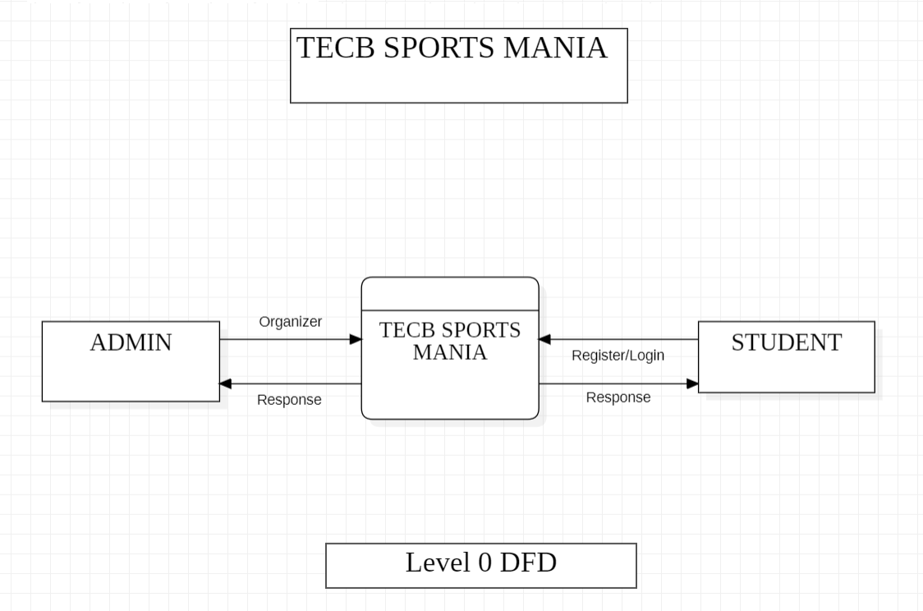

11.1 LEVEL 0 DATA FLOW DIAGRAM

**Description:**

The Admin organizes sports events/activities, and Students can register/login to participate. It shows the main entities (Admin and Students) and the central process that facilitates the registration and organization.

* **LEVEL 1 DATA FLOW DIAGRAM**

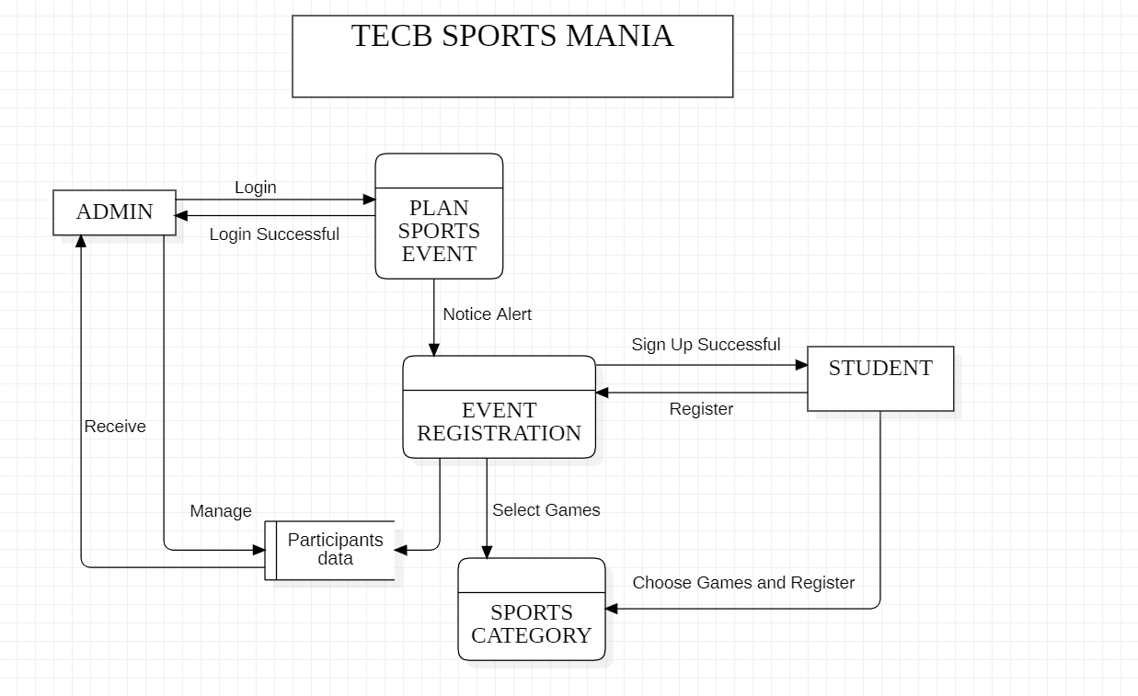

11.2 LEVEL 1 DATA FLOW DIAGRAM

**Description:**

The Level 1 Data Flow Diagram illustrates the overall process flow and main entities involved in a sports event management system. The ADMIN entity logs in to PLAN SPORTS EVENT, while STUDENT entity registers for EVENT REGISTRATION after receiving a notice alert. Students can SELECT GAMES from SPORTS CATEGORY and CHOOSE GAMES AND REGISTER. They also CREATE INDIVIDUALLY their PROFILE. The ADMIN manages PARTICIPANTS DATA and other aspects. Data flows include login, registration, game selection, profile creation, and participant management. The diagram provides a high-level overview of the system, highlighting the interactions between entities, processes, and data movement for effective event planning and participation.

* **LEVEL 2 DATA FLOW DIAGRAM**

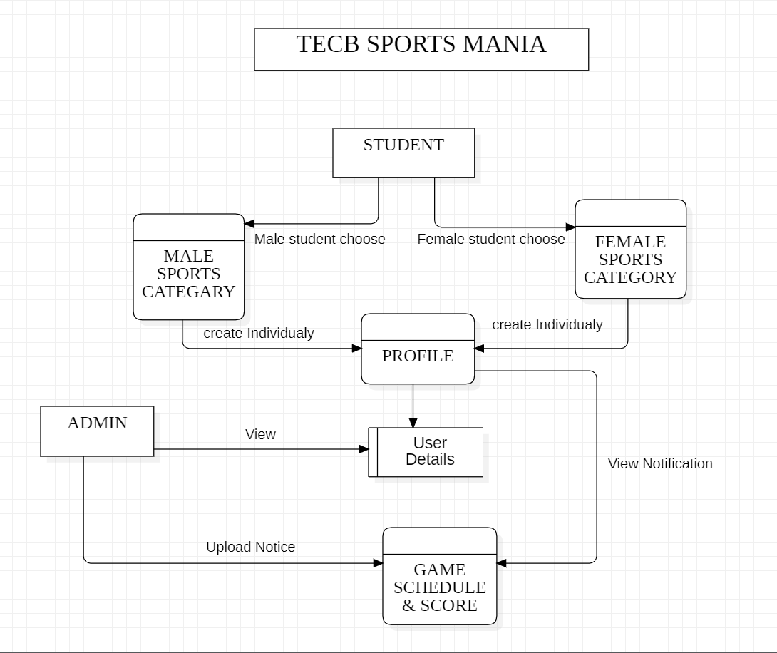

11.3 LEVEL 2 DATA FLOW DIAGRAM

**Description:**

The level 2 data flow diagram (DFD) of TECB Sports Mania depicts the process flow for students and administrators. Students can choose to participate in either male or female sports categories, creating their profiles individually. The admin has the ability to view user details and upload notifications. The "GAME SCHEDULE & SCORE" process receives inputs from both the admin's upload notice and the student's profile creation. Additionally, students in the female sports category can view notifications, facilitating communication and updates regarding game schedules and scores.

**12. USE CASE DIAGRAM**

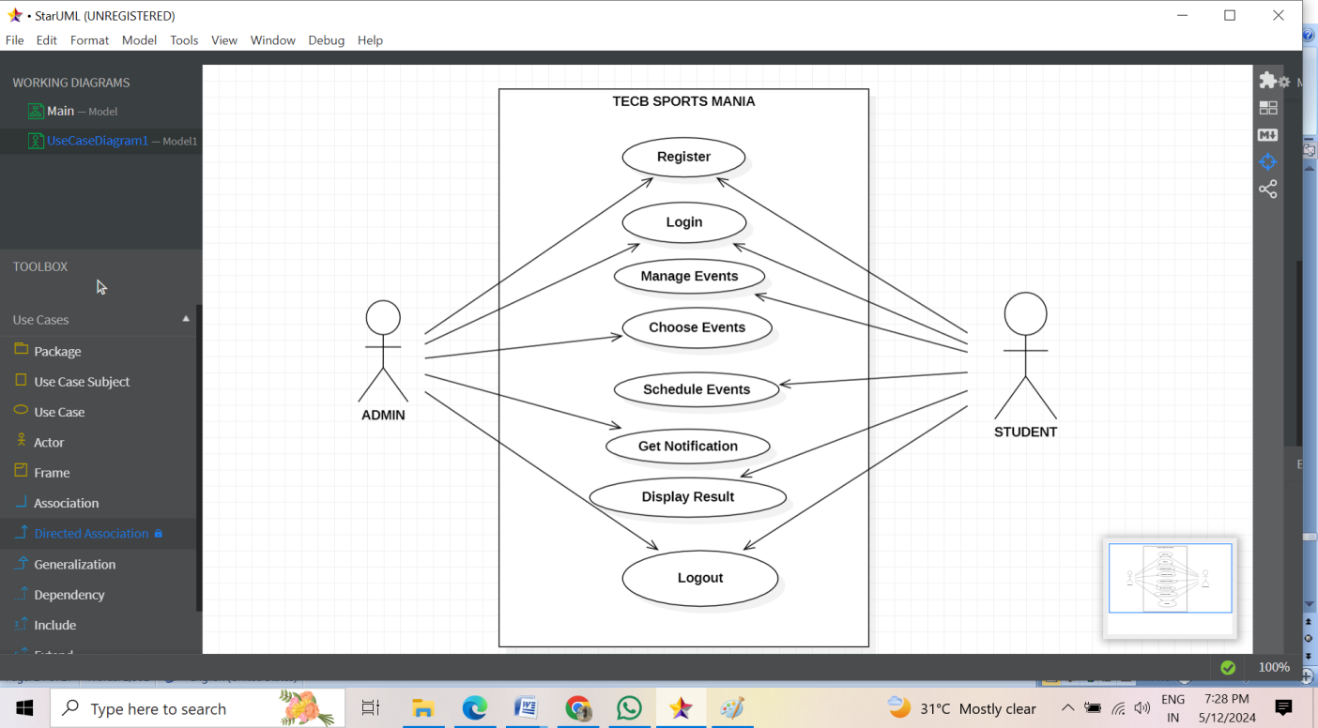

**12.1 USE CASE DIAGRAM**

**DESCRIPTION:**

The use case diagram for the "TECB SPORTS MANIA" project illustrates the main functionalities of the system for both the admin and student actors. The admin can manage events, schedule events, and send notifications, while students can register, login, choose events, and view results. Both actors share the ability to login and logout of the system. This diagram provides an overview of the key interactions between the users and the sports management application.

**13. OUTPUT**

* **HOME PAGE:**

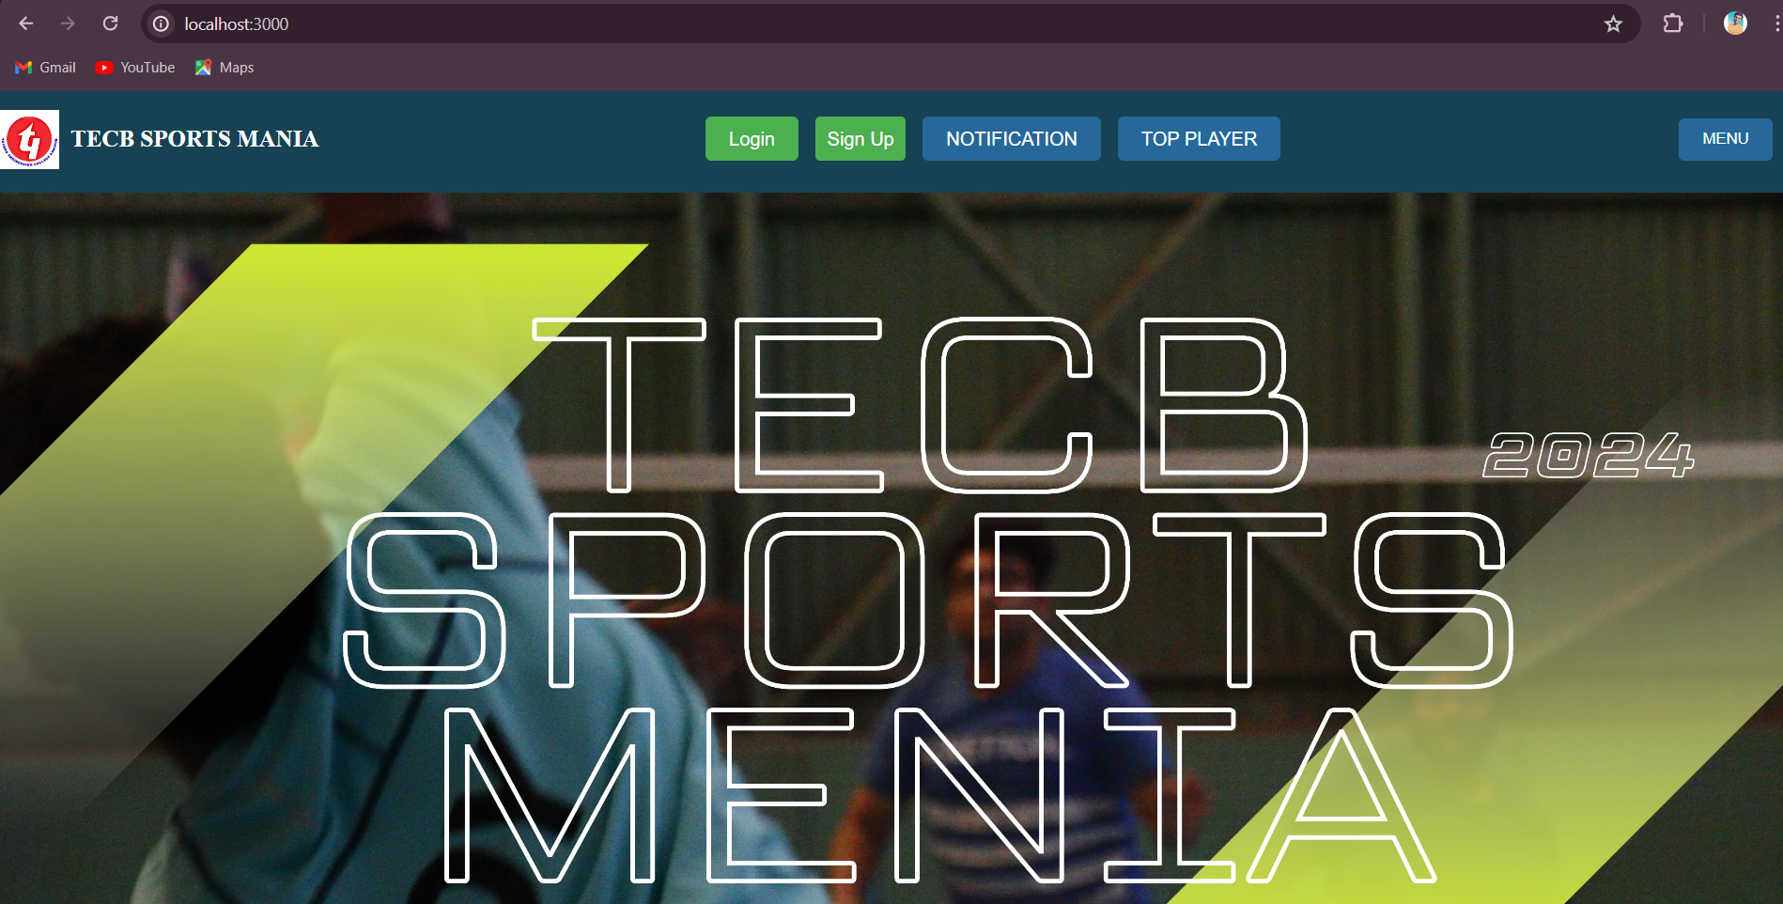

* **USER SIGN UP PAGE/REGISTER PAGE:**

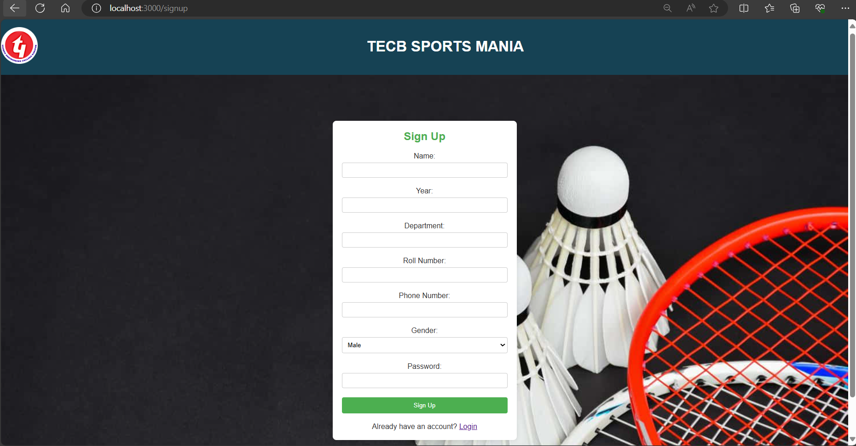

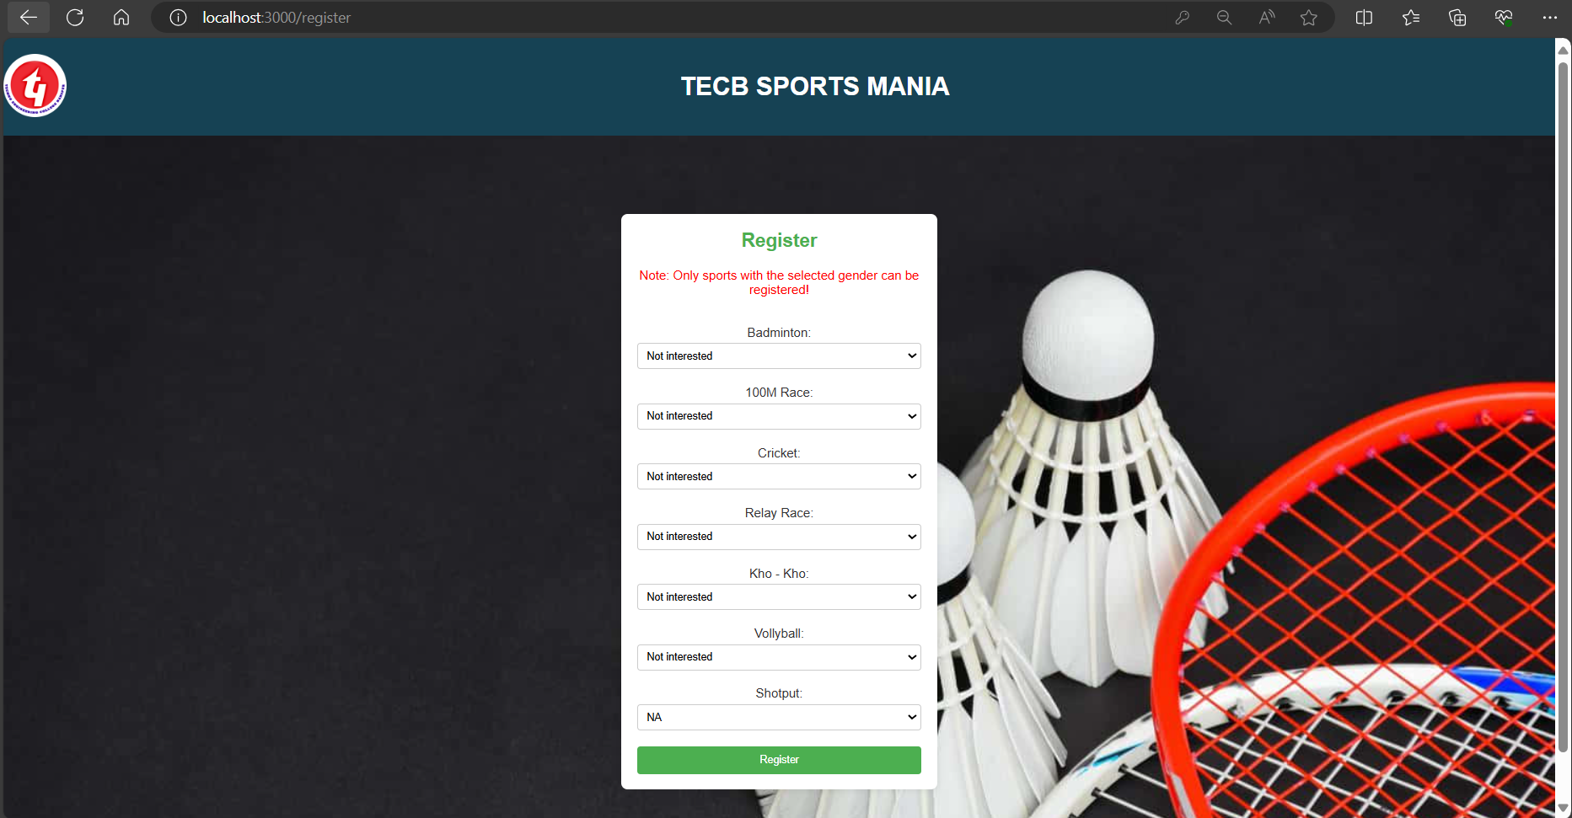

* **USER LOGIN PAGE:**

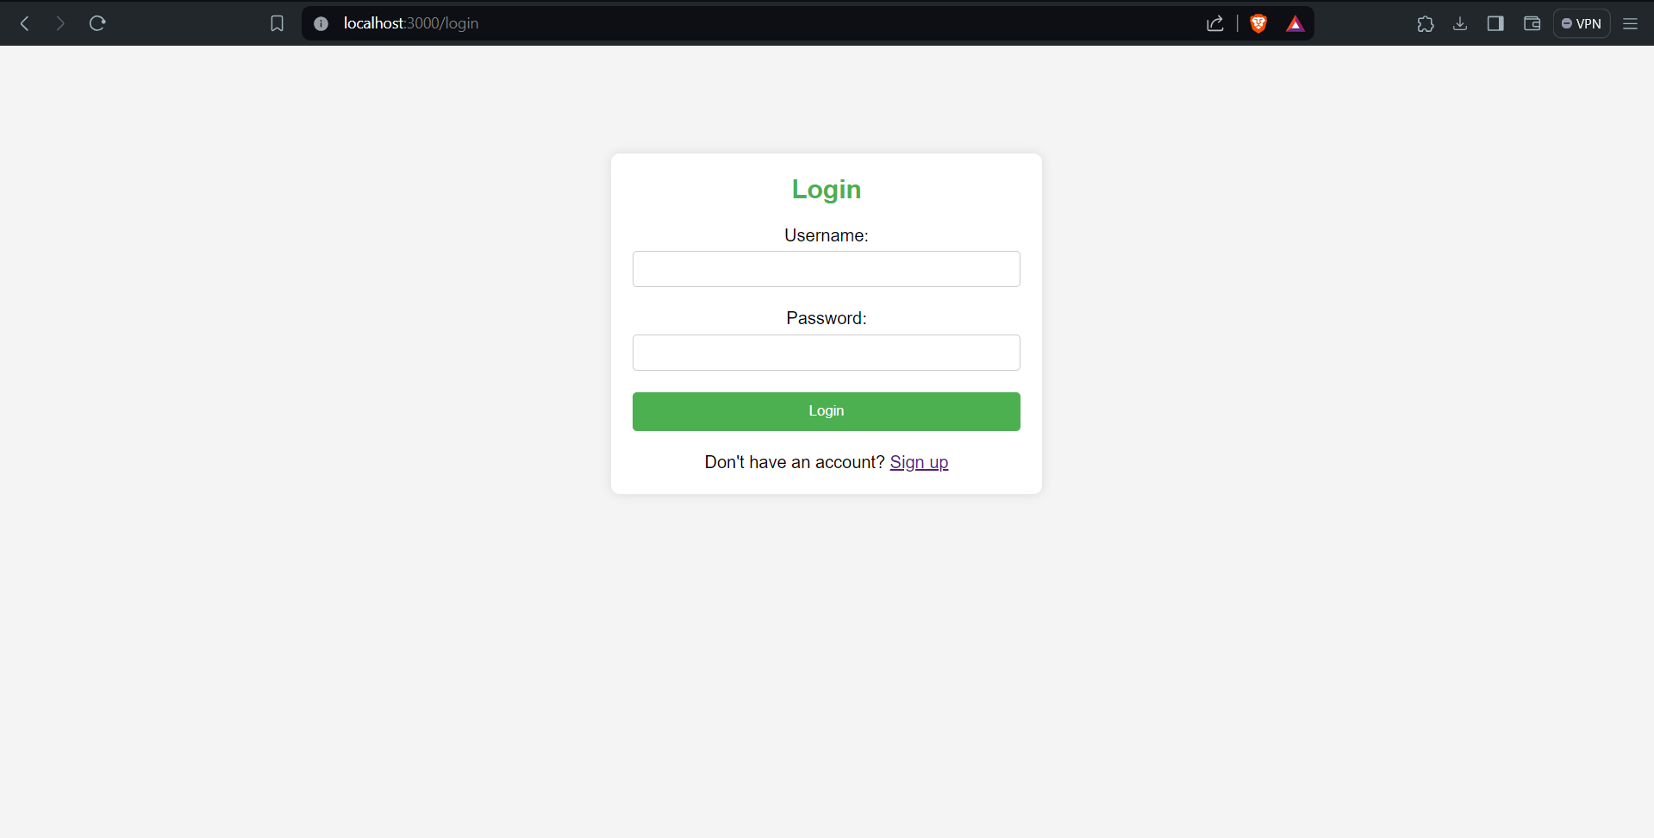

* **ADMIN LOGIN PAGE:**

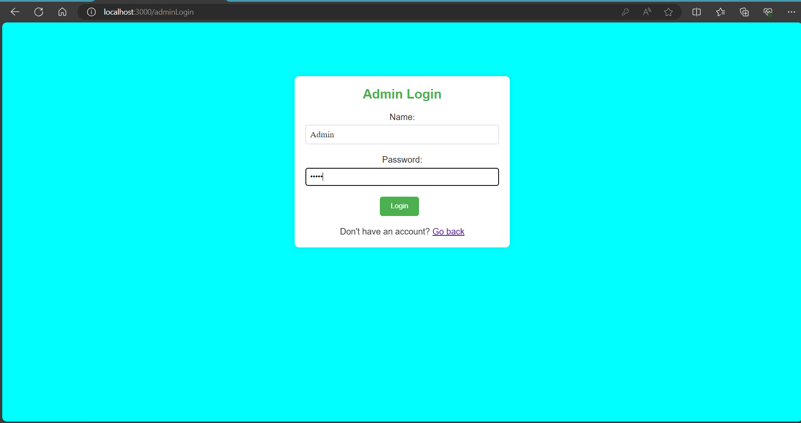

* **SCHEDULE & SCORE PAGE:**

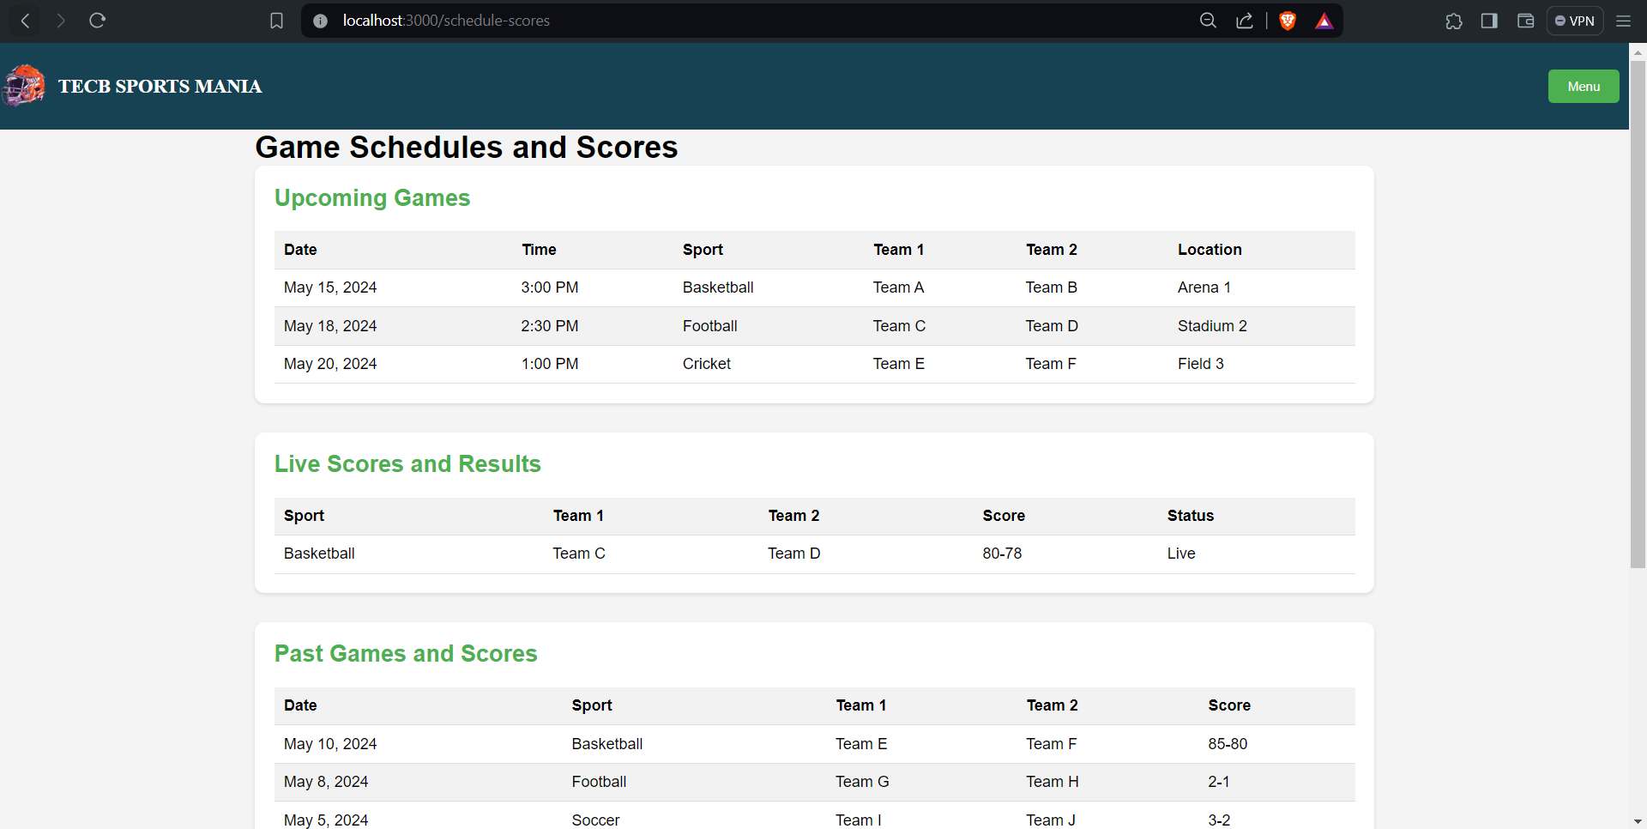

* **TOP PLAYER PAGE:**

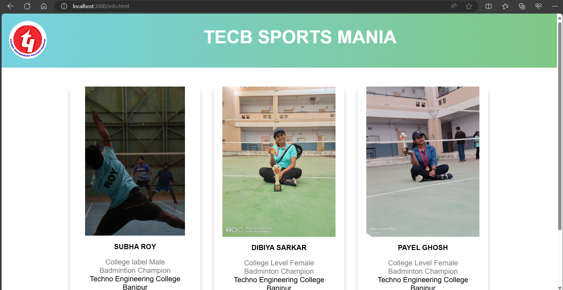

* **ADMIN PANEL PAGE:**

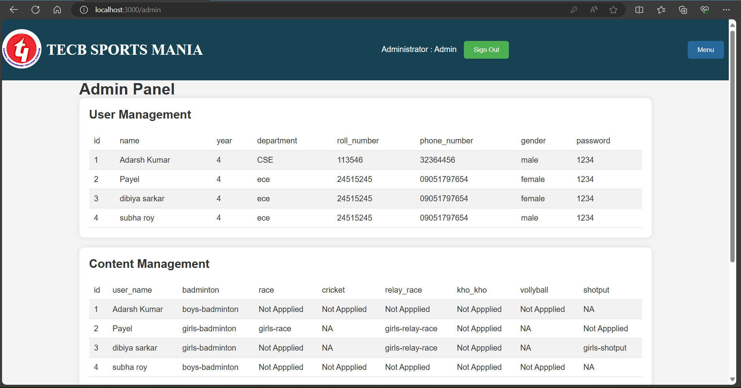

* **ABOUT US PAGE:**

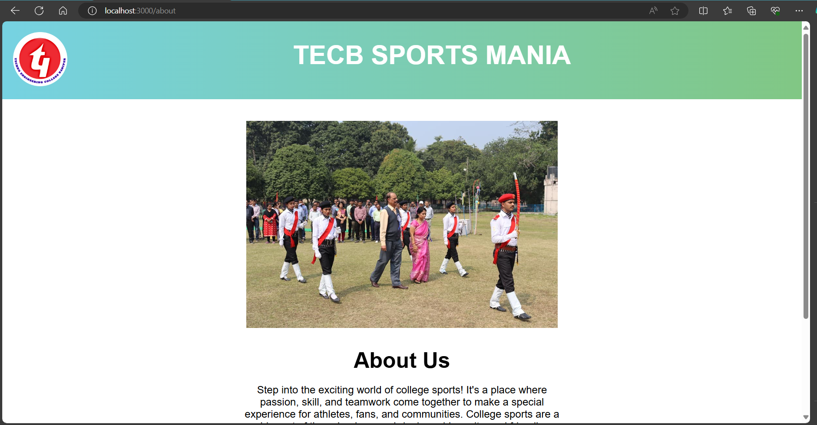

**14. REPORT GENERATION**

This section provides insights into the reporting functionality and the types of reports available to users. Some of the reports that to be generated are listed below:

* Register/Login
* Database connected
* Event Participation Reports
* **Performance Statistics Reports**
* User Activity Reports
* Sign out

**15. SCOPE AND FURTHUR ENHANCEMENT**

* **Mobile Applications:** Create intuitive mobile apps for athletes, coaches, and staff to manage schedules, track performance, and access resources on-the-go.

Authentication and authorization mechanisms for secure access.

* **Advanced Analytics:** Incorporate comprehensive data analytics tools to analyze player performance, game statistics, and training outcomes.
* **Customizable Reports:** Develop customizable reporting features for coaches, athletic directors, and administrators to generate specific insights and metrics.
* **Real-time Updates:** Implement real-time notification systems for schedule changes, announcements, and emergency alerts.
* **Recruitment Management:** Develop modules for managing recruitment processes, including tracking prospective athletes and organizing recruitment events.
* **Event Management:** Enhance capabilities for organizing and managing sports events, including logistics, ticketing, and volunteer coordination.
* **Alumni Networks:** Create platforms for engaging alumni, facilitating networking, mentorship, and fundraising opportunities.

**16. CONCLUSION**

The TECB SPORTS MANIA project successfully created a web-based platform to enhance the management and participation in sports events at Techno Engineering College Banipur. By leveraging modern web technologies such as HTML, CSS, JavaScript, Node.js, Express.js, and MySQL, the platform delivers a user-friendly interface and comprehensive functionalities for event scheduling, team management, and real-time updates. This innovative solution addresses the inefficiencies of traditional manual methods, providing streamlined processes, improved communication, and secure data management. The project not only fulfills current requirements but also establishes a robust framework for future enhancements and scalability. TECB SPORTS MANIA exemplifies a significant advancement in sports management at the college, ensuring an organized, efficient, and engaging experience for students and organizers. This initiative underscores the potential for technology to transform and modernize sports administration, setting a new standard for future projects.

**17. REFERENCE**

* <https://www.scribd.com/document/229356010/sports-management>
* <https://www.irjmets.com/uploadedfiles/paper/volume3/issue_7_july_2021/14234/1628083553.pdf>
* <https://github.com/>
* <https://stackoverflow.com/>
* <https://www.academia.edu/35737229/Project_Report_Sport_Event_Management_System_Submitted_to>
* <https://www.slideshare.net/slideshow/sports-event-management-systemreport/57434610>